BENAZIR BHUTTO SHAHEED UNIVERSITY LYARI, KARACHI

REPORT
IMAGE SEGMENTATION USING GRAPH CUTS AND CONSTRAINT CLUSTERING – FULL
Submitted by:

Ariba M Saleem | [B2331022]
Ayesha Awan | [B2331027]
Daniyal Hanif | [B2331034]

1. Introduction
Image segmentation is the process of dividing an image into meaningful and identifiable regions. It
helps computers understand what objects are present in an image and where they are located.
Why Image Segmentation Is Important:
- Helps computers interpret visual data
- Used in medical imaging (tumor detection)
- Used in object detection (cars, humans, animals)
- Essential for robotics and autonomous vehicles
Purpose of This Project:
This project compares two segmentation techniques:
1. Graph Cuts (GrabCut Algorithm)
2. Constraint Clustering (K-Means using LAB + XY features)
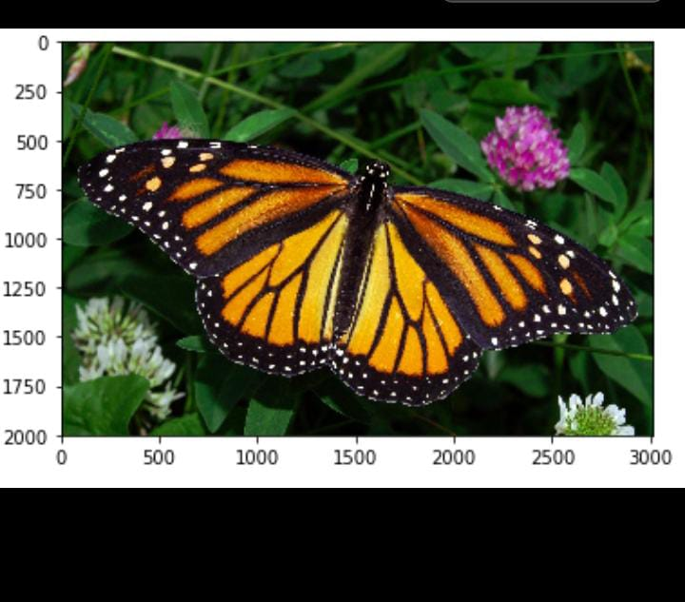
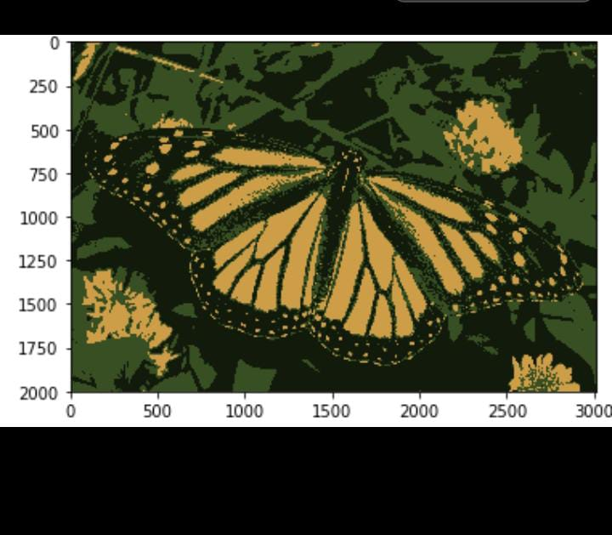
2. GrabCut (Graph Cuts) Method
How GrabCut Works:
1. Image loaded using cv2.imread()
2. Rectangle drawn around object (bounding box)
3. Graph created from pixel relationships
4. GrabCut executed using:
cv2.grabCut(image, mask, rect, bgModel, fgModel, iterations, mode)
Final output gives clear foreground 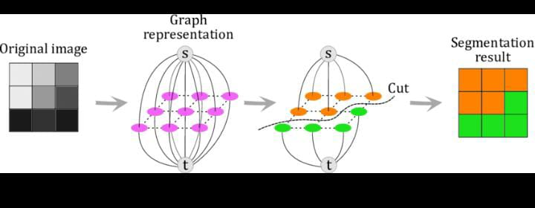

Why GrabCut Works Well:
- Sharp boundaries
- Good with clear foreground/background differences
- Improves with each iteration
3. Constraint Clustering (K-Means)

Why Constraints Are Needed:
Without constraints, K-Means becomes noisy and inaccurate.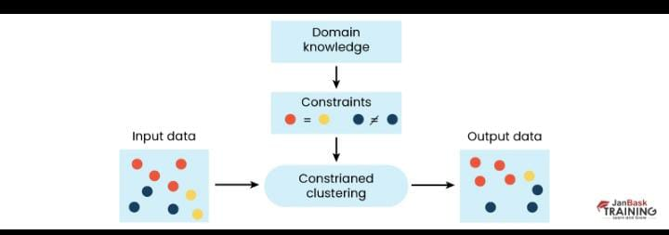
Types of Constraints:
- Spatial Constraints: nearby pixels grouped
- Shape Constraints: object shape preserved
- Topological Constraints: connected components intact
Deep Learning + Constraints:
- CNNs or Transformers learn features
- Constraints maintain logical consistency
4. Errors and Fixes
Common Errors:
- Over-segmentation
- Weak boundaries
Fixes:
- Applied morphological operations
- Improved GrabCut iterations
- Adjusted K-means cluster values
5. Dataset Details (BSDS500)
Includes:
- Complex natural images
- Ground truth segmentations
Objects like people, animals, buildings
6. Results
Model | Pixel Accuracy | IoU Score
GrabCut | 92.5% | 83.7%
K-Means | 85.4% | 72.1%
7. Best Model
GrabCut performed best due to:
- Clean boundaries
- Strong accuracy
- High IoU
8. Worst Model
K-Means performed worst because:
- Weak edge detection
- Over-segmentation
- Poor handling of complex backgrounds
Accuracy: 85.4%
IoU: 72.1%

9. Conclusion
- GrabCut is the best performing method
- K-means is fast but less accurate- Constraints improve clustering but still weaker than GrabCut

